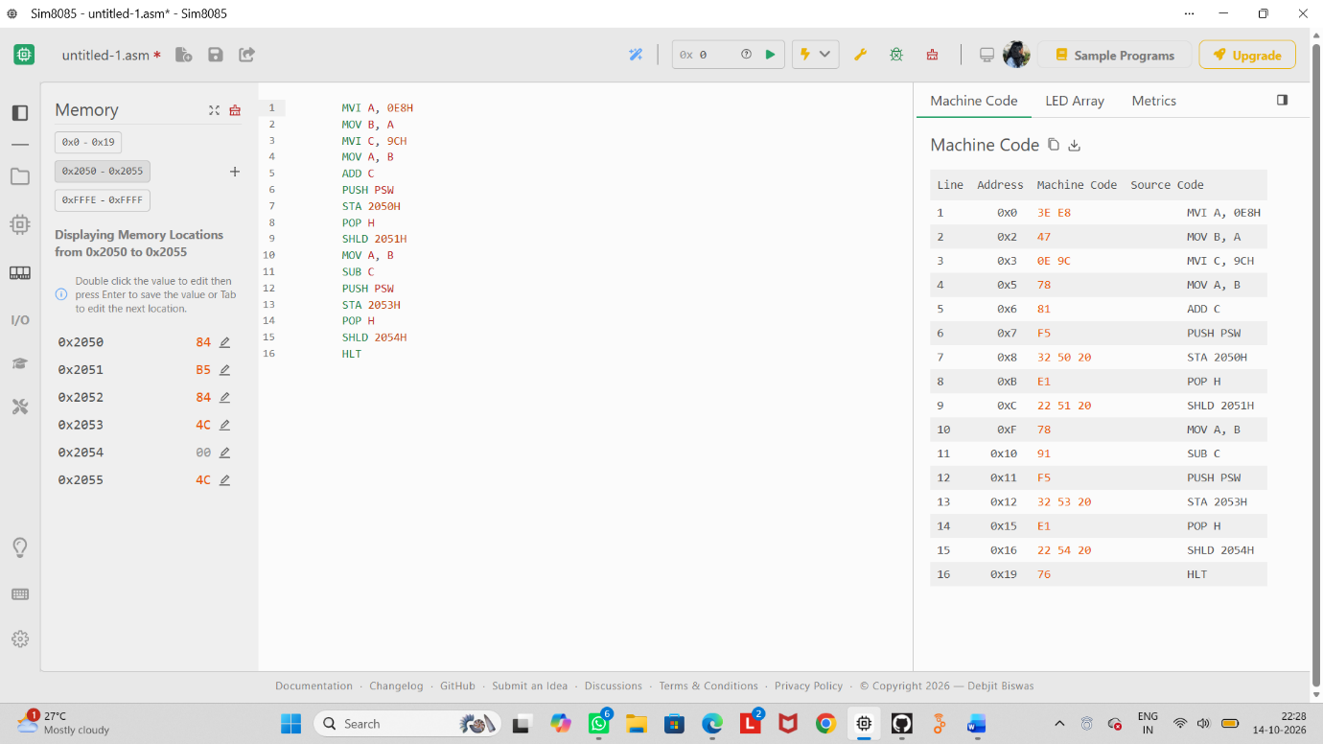
2. For A = E8H, B = 9CH record S, Z, AC, P and CY after addition and subtraction using PUSH PSW, find signed overflow manually, identify the cases where CY and overflow differ, and justify each flag using the signed and unsigned interpretation of the operands. develop 8085 code

